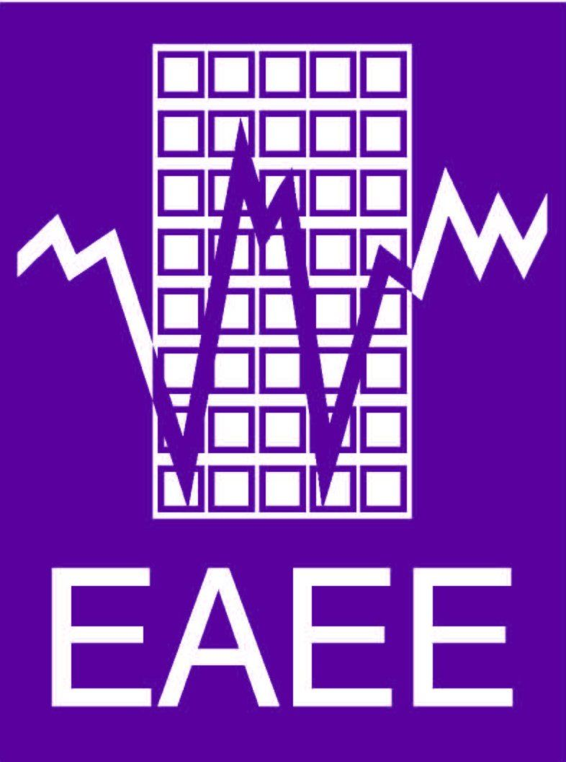
Young Professionals Application Form

European Regional Seminar on Induced Seismicity due to Human Activities
11-14th of May, 2020, Groningen, Netherlands

European Association of Earthquake Engineering (EAEE)
Dutch Earthquake Engineering Association (DEEA)

Name / Surname of the Applicant

Affiliation

Age & Gender

Motivation to Participate (Max 200 words)

Would you like to present in the Young Professionals Sessions?
The Seminar is organized in a way that invited experts from Europe will present on certain themes while there will also be following sessions dedicated to the Young Professionals. The Young Professionals presentation duration will be limited to 15min including questions. If you would like to present your work related to induced seismicity, please indicate a tentative presentation title, co-authors (if any) and a brief description of the content at max 100 words. Please indicate in which theme you would like to present. For the 6 themes of the Seminar, please refer to the announcement at:
(https://www.deea.nl/wp-content/uploads/2019/12/1st_Announcement_v4-2.pdf)

Please note that by filling this application, you accept to participate the entire event from 11th to 14th of May 2020 in Groningen, Netherlands

Below are our Selection Criteria
- Geographic distribution (minimum 1 – if any application- , and maximum 2 persons per country)
- Background on earthquake engineering is required
- Past or present work on induced seismicity is preferable
- Gender equality will be applied as a selection criterion

